**NAME: NADIYE ENOSI PETER**

**ACCESS NUMBER: B24326  
REG NUMBER: S23B13/040**

**VIRTUAL CLASS SYSTEM**

A **virtual classroom** is an online learning environment that replicates the physical classroom experience using digital tools and technologies. In a virtual classroom, teachers and students interact in real-time or asynchronously via the internet, with the primary goal of providing education regardless of physical location. This system has gained significant popularity due to its flexibility, accessibility, and the ability to accommodate students globally.

**Key Components of the Virtual Classroom:**

1. **Real-Time Interaction**:
   * Tools like video conferencing (e.g., Zoom, Microsoft Teams) allow for live lectures, discussions, and interactions between teachers and students.
   * Features like virtual whiteboards, screen sharing, and chat enable active participation.
2. **Learning Management Systems (LMS)**:
   * Platforms such as Moodle and Google Classroom organize courses, store learning materials, manage assignments, and track progress.
   * These systems allow teachers to upload content (lectures, reading materials, quizzes) and manage student data (grades, attendance, etc.).
3. **Content Delivery**:
   * Recorded lectures, readings, and multimedia content are provided to students, allowing them to access material at their own pace.
   * Quizzes, exams, and assignments are also distributed through the platform, with deadlines and instructions for submission.
4. **Collaboration Tools**:
   * Discussion boards, chat rooms, and group projects facilitate collaboration between students.
   * Instructors can use breakout rooms for small-group discussions during live sessions.
5. **Assessment and Feedback**:
   * Virtual classrooms offer online quizzes, exams, and assignment submissions.
   * Teachers can grade assignments, provide feedback, and track performance in real-time.
6. **Personalized Learning**:
   * Adaptive learning systems can be integrated into virtual classrooms, allowing students to receive customized learning paths based on their performance and learning preferences.
7. **Communication Channels**:
   * Email, messaging, and notifications are built into virtual classroom systems to help students and teachers stay connected.

**Advantages of a Virtual Classroom:**

* **Accessibility**: Students from different parts of the world can attend classes without having to be physically present.
* **Flexibility**: Learning can happen synchronously (live sessions) or asynchronously (pre-recorded materials), allowing students to learn at their own pace.
* **Cost-Effective**: Virtual classrooms often reduce costs related to commuting, infrastructure, and study materials.
* **Diverse Resources**: Digital platforms can host multimedia materials, enriching the learning experience with videos, simulations, and interactive exercises.
* **Collaboration**: Virtual classrooms foster collaborative learning through discussion boards and group work.

**2. System Overview**

The Virtual Classroom System aims to address common challenges in online learning, such as:

* Limited access to education for students in remote areas.
* Fragmented learning tools that make navigation between content and tasks difficult.
* Reduced engagement due to lack of interactivity and collaboration.
* Difficulty in tracking student progress and managing assessments for teachers.

The system consists of core functionalities like:

* **User Authentication**: For teachers and students to log in.
* **Course Management**: Teachers can create courses, upload materials, and manage enrolled students.
* **Assignment Submission**: Students can view and submit assignments for evaluation.
* **Grading and Feedback**: Teachers can review and grade assignments, providing feedback directly within the system.
* **Interactive Tools**: Including chat, forums, and video conferencing for live classes.

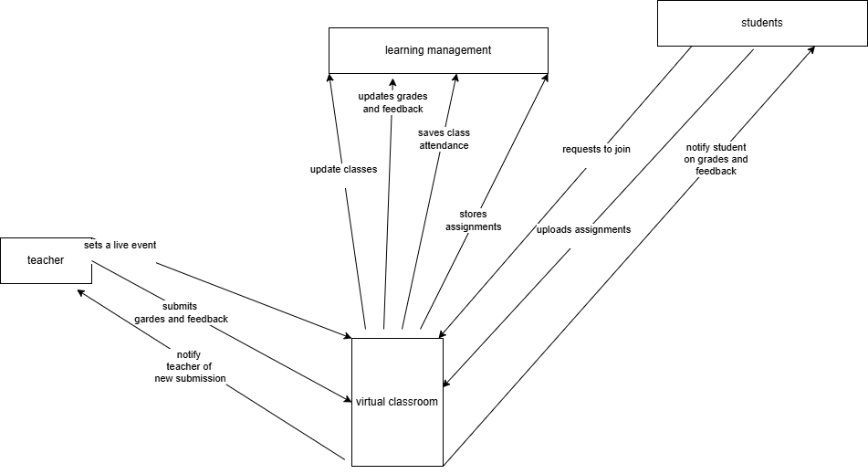

**Class Diagram Explanation**

The **UML Class Diagram** provides a structural representation of the system, showing the key entities and their relationships. The main classes include:

* **User Class**:
  + Attributes: user ID, name, email.
  + Methods: login (), logout ().
  + This is the superclass for all users in the system, defining the basic properties and behaviors that both **Student** and **Teacher** share.
* **Student Class** (inherits from User):
  + Attributes: student ID, enrollment Status.
  + Methods: view Grades (), enroll Course (), submit Assignment ().
  + The Student class extends the User class and includes actions specific to students, such as enrolling in courses and submitting assignments.
* **Teacher Class** (inherits from User):
  + Attributes: teacher ID, department.
  + Methods: upload Material (), grade Assignment (), view Submissions ().
  + The Teacher class handles course creation, material upload, and assignment grading.
* **Course Class**:
  + Attributes: coursed, course Name, description.
  + Methods: add Material (), list Students (), assign Task ().
  + The Course class manages the courses available in the system, storing course materials and keeping track of both students and assignments.
* **Assignment Class**:
  + Attributes: assignment ID, due Date, status.
  + Methods: submit (), grade ().
  + This class represents assignments within a course, allowing students to submit and teachers to grade them.
* **Material Class**:
  + Attributes: material ID, type, content.
  + Methods: upload (), download ().
  + Represents educational resources (such as lectures, documents, and videos) that are part of a course.

The relationships between the classes include:

* **Inheritance**: Student and Teacher classes inherit from User.
* **Associations**: Courses are associated with both Students and Teachers. Each Course can have multiple Assignments and Materials.

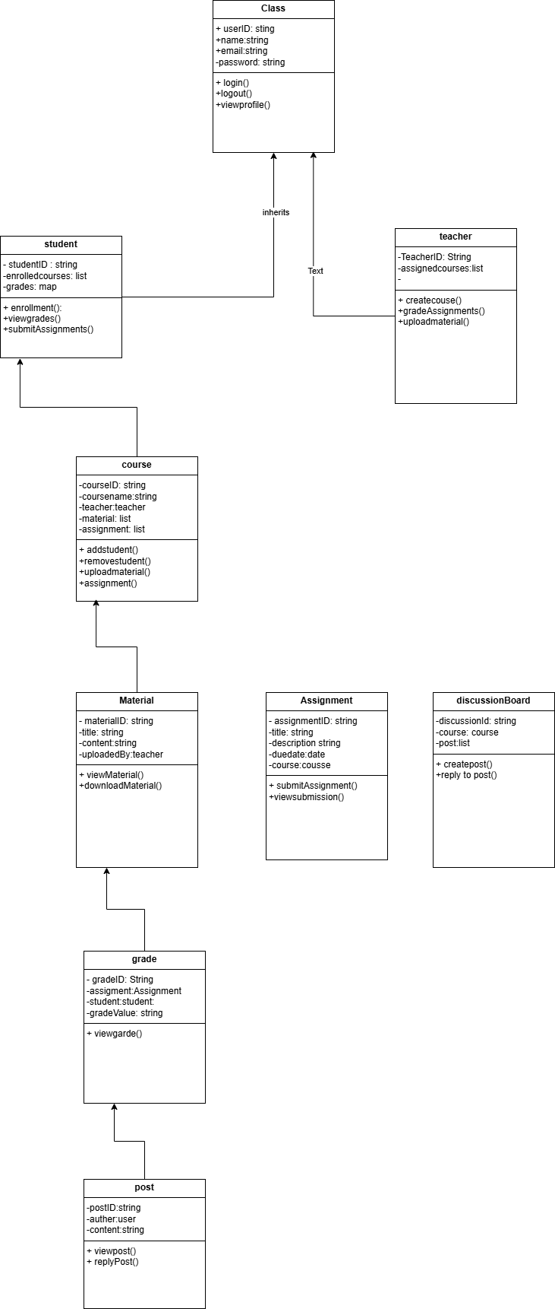

The **Sequence Diagram** illustrates the flow of interactions between users (students and teachers) and the system’s components. Below is an explanation of the key interactions:

* **Student Use Case**:
  1. The student logs into the system.
  2. They view available courses and select a course.
  3. The system retrieves and displays course materials and assignments.
  4. The student submits an assignment.
  5. They log out of the system.
* **Admin use Case**

1. Admin logs into the system.  
 2. They view the login history of the students and teachers  
 3.they manage the access levels  
 4.check for the activity and attendance records

* **Teacher use case**
  1. The teacher logs into the system.
  2. They view submissions from students.
  3. The teacher grades the assignments.
  4. Feedback is sent back to the students.
  5. The teacher logs out.

DIAGRAM

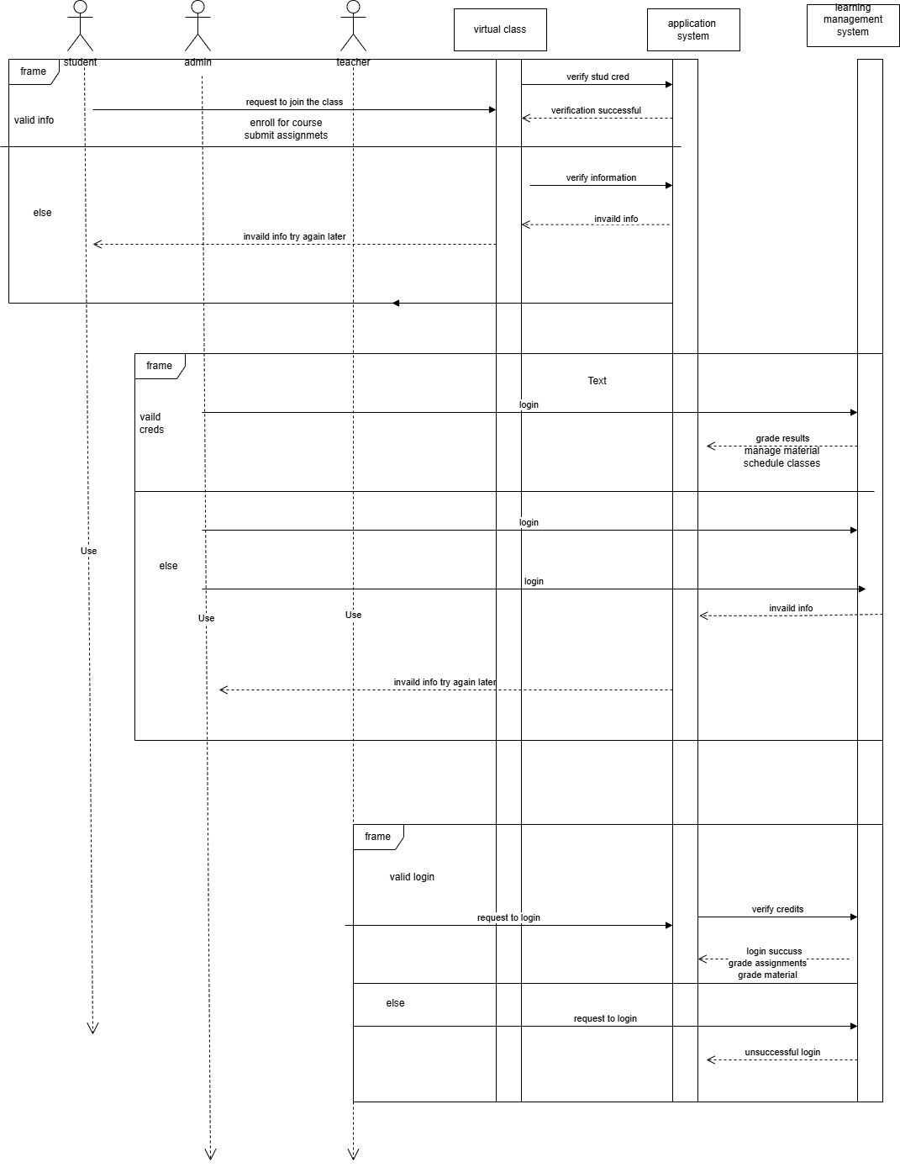

**Use Cases for Each Actor**

**Student Use Cases:**

* **Login**: Students must log in to access the system's features.
* **View Courses**: After logging in, the student can view the list of courses they are enrolled in.
* **Submit Assignment**: Students can submit their completed assignments for grading through the system.
* **View Grades**: Students can check the grades provided by the teacher after grading.
* **Join Class**: Students can participate in live or recorded virtual classes through the platform.

**Teacher Use Cases:**

* **Login**: Like students, teachers also need to log in to access their functionalities.
* **Create Course**: Teachers can create new courses and define course materials, assignments, and structure.
* **Upload Material**: Teachers can upload lectures, reading materials, videos, and other educational resources for their courses.
* **Grade Assignment**: Teachers review submitted assignments and assign grades to students.
* **Manage Course**: Teachers can edit or update courses, remove students, and manage overall course settings.

**Admin Use Cases:**

* **Login**: The admin logs into the system to perform administrative duties.
* **Manage Users**: Admins can add, remove, or update user information for both students and teachers.
* **Manage System Settings**: Admins have the ability to adjust system-wide settings, such as user access levels, maintenance schedules, and other configurations.
* **Monitor Activity**: Admins can track and monitor activities within the system, such as course enrollments, assignment submissions, and system usage statistics.

**3. Associations**

* Each actor is connected by lines to the use cases they are involved in. These associations show which actor interacts with which part of the system. For example, both **Student** and **Teacher** are linked to the "Login" use case, showing that logging in is a shared functionality

IMAGE OF THE USE CASE

